ServiceMaster Deerfield IL - Specialty Cleaning Projects – Commercial and Residential Services

ServiceMaster By Simons, the North Shore’s leader in Specialty Emergency Cleaning Services for residential and commercial properties in Deerfield Illinois.
Deerfield Illinois, a quiet suburb near the water front region Lake County Illinois is home to some mega-corporations like Walgreens, Baxter Healthcare and Takeda Pharmaceuticals and amazing outdoor shopping at the new Deerfield Square. Originally populated by the Potawatomi Native Americans, Deerfield became a residential hub due to the convergence of two main rivers, the Des Plaines and the Chicago Rivers. More recently, Deerfield was the home of the Chicago Bulls practice facility before taking it to Chicago.
ServiceMaster By Simons, a woman-owned and family-operated business, knows the North Shore’s Deerfield community and has served its property owners, managers and agents for over 30 years. Our technicians are IICRC Certified and are industry leaders in Residential & Commercial services including Master Textile Restoration.
With a brand new North Shore facility, we are fully equipped and ready to respond to our Deerfield IL customer’s cleaning needs immediately. ServiceMaster By Simons is a family-operated company that cares about customer satisfaction and providing professional, quality service to residential and commercial property owners, managers and agents.
ServiceMaster By Simons is proud to offer Deerfield Illinois residents and business owners, quality & professional cleaning services.
Contact ServiceMaster By Simons now! Schedule a professional cleaning services for your Deerfield IL home or business now. Not just clean. ServiceMaster Clean!

ServiceMaster Des Plaines IL – Specialty Cleaning Projects – Commercial and Residential Services

ServiceMaster By Simons, the North Shore’s premiere service provider offers quality, Emergency Specialty Cleaning Services in Des Plaines IL
Just 20 miles northwest of Chicago, Des Plaines Illinois has a past richly steeped in Native American history, including the Potawatomi, Ottawa and Chippewa tribes.
Today, Des Plaines, Illinois has a thriving restaurant and entertainment scene which includes the world famous Rivers Casino, the McDonalds Museum and the Des Plaines Theater.
ServiceMaster By Simons, a woman-owned and family-operated business knows the Des Plaines IL community well and is proud to provide IICRC certified cleaning and specialty cleaning services to homes, businesses and educational institutions in Des Plaines, Illinois. As a certified Master Textile Restoration company, we ensure proper care of your property whether you’re an owner, manager or agent.
With our new North Shore facility, located in Skokie Illinois, our friendly staff can be at your commercial or residential property in a timely manner to assess and consult with you for the specialty cleaning project you require.
For more information, or to schedule services, contact ServiceMaster By Simons or call us at 847-316-9145.
Not Just Clean – ServiceMaster Clean!

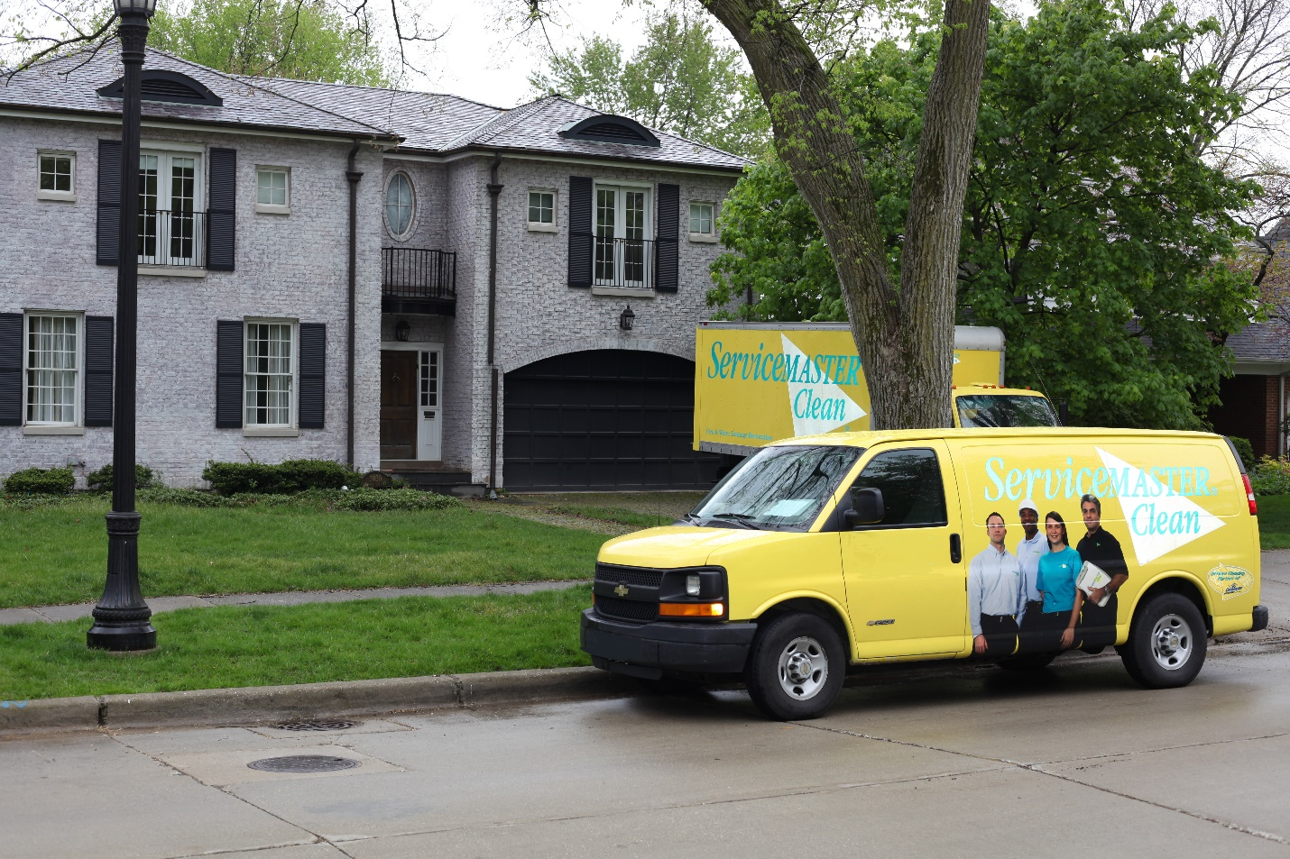

ServiceMaster Evanston IL - Commercial and Residential Services - Specialty Cleaning

ServiceMaster By Simons, the North Shore’s leader in Emergency Specialty Cleaning service, provides professionally certified services for property owners, managers and real estate professionals in Evanston Illinois
Evanston, Illinois is home to one of the world's greatest institutions of higher learning, Northwestern University. Along with it, the city is well known for its great restaurants, burgeoning night life and its many shopping districts, including Central Street, Downtown Evanston, Dempster Street, Main Street Station, the up-and-coming Howard Street and Chicago Avenue. Bordered by Wilmette, Illinois, Chicago and Skokie, Illinois, Evanston is in a unique water-front position as a destination point for both city dwellers as well as North Shore residents.
Evanston IL is also the home of ServiceMaster By Simons, a woman-owned and family-operated business! As a proud member of the community and a member of the Evanston Chamber of Commerce, ServiceMaster By Simons is proud to deliver the highest quality service to homes and businesses in Evanston Illinois as leaders in textile restoration.
Your property requires the finest professional specialty cleaning services. That's why ServiceMaster By Simons is Evanston's leader in Specialty Cleaning Services and sets the benchmark for "clean," ServiceMaster Clean!
ServiceMaster By Simons Evanston IL is an IICRC certified Master Textile Restoration firm.
Contact ServiceMaster By Simons today at 847-316-9145 and schedule to get your property clean - ServiceMaster Clean.

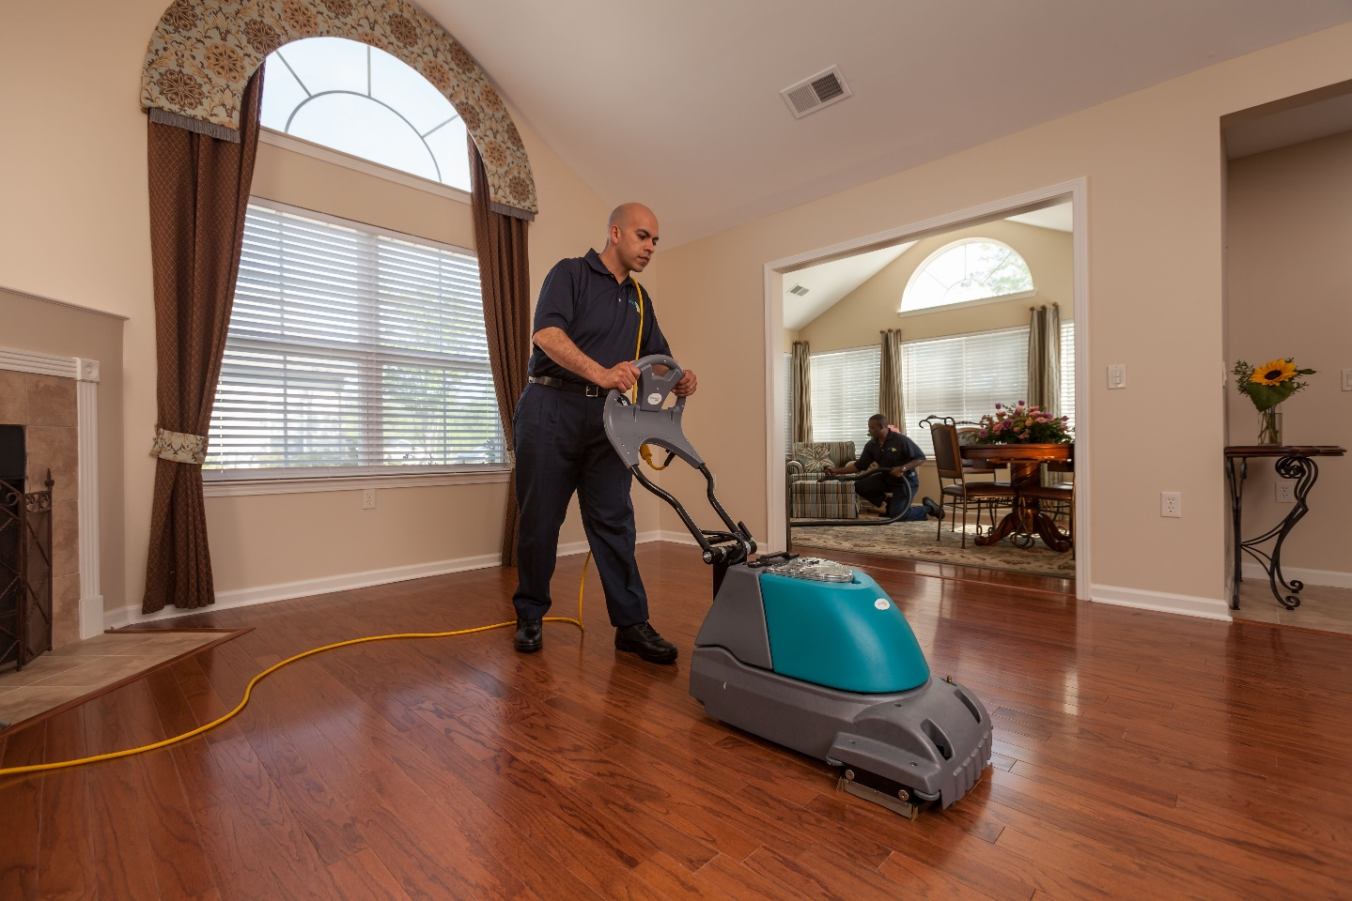

ServiceMaster Glencoe IL - Commercial & Residential Services - Specialty Cleaning - ServiceMaster By Simons

ServiceMaster By Simons, serving the North Shore of Cook & Lake County IL, provides Emergency Specialty Cleaning Services to Commercial and Residential customers in Glencoe Illinois
Insulated by over 1,200 acres of natural forest and Cook County Forest Preserve, the water front town of Glencoe IL is an ideal community to live and raise a family. Surrounded by upper income communities including Highland Park, Northbrook and Winnetka, and three Country Clubs including the Lake Shore Country Club, Glencoe Golf Club and the Skokie Country Club, Glencoe is definitely one of the North Shore's gems.
That's why it's important to choose the right service-provider when searching for Residential or Commercial Specialty Cleaning services in Glencoe IL.
ServiceMaster By Simons, a woman-owned and family-operated company in Chicago, Oak Park and the North Shore, is the trusted name for Emergency Specialty Cleaning services in Glencoe IL and its surrounding towns and villages.
ServiceMaster By Simons' convenient location in Skokie IL means that we offer great services with lesser travel times and more options for scheduling your service. We pride ourselves on excellent service and strive for customer satisfaction every time. As an IICRC certified firm in Master Textile Restoration, we take special interest in providing the finest, fastest services around!
Contact ServiceMaster By Simons to immediately schedule your services or call us at 847-316-9145 or toll free at 855-9-SIMONS.

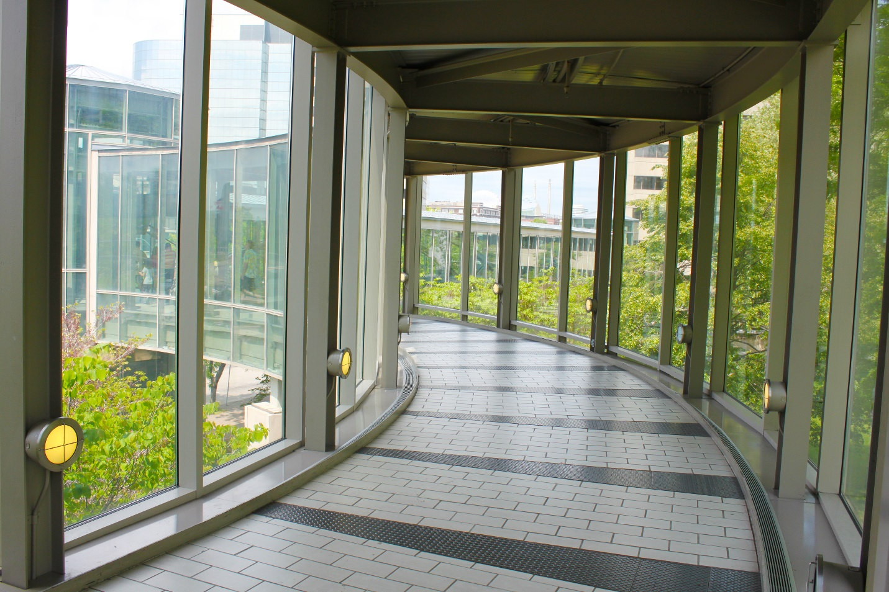

ServiceMaster Glenview IL – Specialty Cleaning Service – Emergency Scheduling

ServiceMaster Glenview IL, northwest suburbs leader in Specialty Cleaning for Commercial & Residential properties, provides Specialty services to home-owners and business-owners of Glenview IL
ServiceMaster By Simons legacy of pursuing the highest standards
In 1929 when Marion E. Wade, a former minor league baseball player founded ServiceMaster as a moth-proofing company, little did he know it would grow into a world-class company providing essential residential and commercial services including home warranties, home inspections, furniture repair and restoration, residential and commercial cleaning, disaster restoration like water and fire damage restoration, and termite and pest control, to more than 75,000 homes and businesses every day.
We’re all about a better clean
We have spent more than 60 years getting to know every kind of client – from homeowners to facility managers to property managers. Our relentless passion for excellence and customer service means we continuously invest in improving our processes, our employees and our relationship with you.
When it comes to cleaning, we don’t mess around
At ServiceMaster By Simons Glenview IL, we have spent years getting to know every kind of client, from homeowners to facility managers to property managers.
When it comes to running your business we know the importance of selecting a reliable, trusted service provider. And when it comes to servicing your property, you want trusted professionals who will treat your home or business like their own and deliver exceptional results.
Our IICRC Certified technicians provide a range of services. As a Master Textile Restoration firm, we’ll take the utmost care of your property.
Why ServiceMaster Glenview IL?
As a woman-owned and family-operated firm, ServiceMaster Glenview IL has taken great pride in meeting and exceeding the expectations of our customers. Behind our commitment to excellence are five key attributes that compose who we are and what sets us apart from other companies.
- We Are Experts and define industry standards in scale and scope with an adaptable, extensive network of ServiceMaster Restore & Clean franchises that consistently deliver exceptional results
- We Are Committed to customer satisfaction and are directed in all we do by their needs.
- We Are Complete and look to provide excellent service and engage in proactive behavior.
- We Are Driven to pursue the highest standards and continuously improve in all aspects of our business.
- We Are Steadfast. ServiceMaster By Simons here for the long haul with consistent service that ensures ongoing customer satisfaction.
For immediate service, contact ServiceMaster By Simons or call us at 847-316-9145.

ServiceMaster Highland Park IL – Residential & Commercial Service - Specialty Cleaning – Emergency Scheduling

ServiceMaster By Simons, the North Shore's leader in emergency Specialty Cleaning Services, provides service to homes and businesses in Highland Park IL including St. John, Port Clinton and Ravinia.
The water front community of Highland Park IL is considered one of the more attractive towns on Chicago's North Shore with its vibrant downtown shopping district and the annual Ravinia Festival.
It also boast several landmark structures listed in the National Register of Historic Places including the Willits House by Frank Lloyd Wright and homes designed by John S. Van Bergan, Howard Van Doren Shaw and David Adler to name a few.
Why ServiceMaster By Simons?
With homes and business districts as historic as Highland Park's, it is important to choose the professionals at ServiceMaster By Simons. With our years of experience and expertise, ServiceMaster By Simons will have your home or business back to clean - FAST!
ServiceMaster By Simons, a woman-owned and family operated firm, is conveniently located in Chicago's North Shore and can be at your home or business in a relatively short time, usually same day. As an IICRC Certified firm in Master Textile Restoration, you can rest assured that you're in good hands.
Contact us and schedule your estimate and consultation or call us at 847-316-9145 for emergency cleaning services.

ServiceMaster Kenilworth Illinois – Residential and Commercial Specialty Cleaning – North Shore Cleaning Services

ServiceMaster By Simons, the north shore’s choice for professional Specialty Cleaning services.

ServiceMaster Near Me
Let’s start out by saying “We Love Kenilworth IL!” Whether we sail at the Kenilworth Beach, watch our kids play at Pee Wee Field or just hanging at the water front, it’s our hidden little enclave on the lakefront.
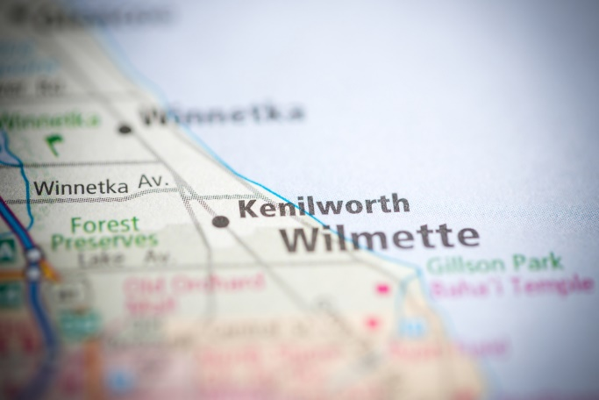
On the water-front and bounded by Wilmette Illinois and Winnetka Illinois, Kenilworth residents have the advantage of enjoying great shopping, restaurants and plenty of other services in the neighboring towns.
ServiceMaster By Simons, a woman-owned and family-operated firm, is proud to provide emergency specialty cleaning services to the residents of Kenilworth IL. As an IICRC certified Master Textile Restoration firm, we have special expertise and take great care to ensure great quality service in your home.
For more information on ServiceMaster By Simons services call 847-316-9145 or click on our website to schedule your estimate, consultation and service.

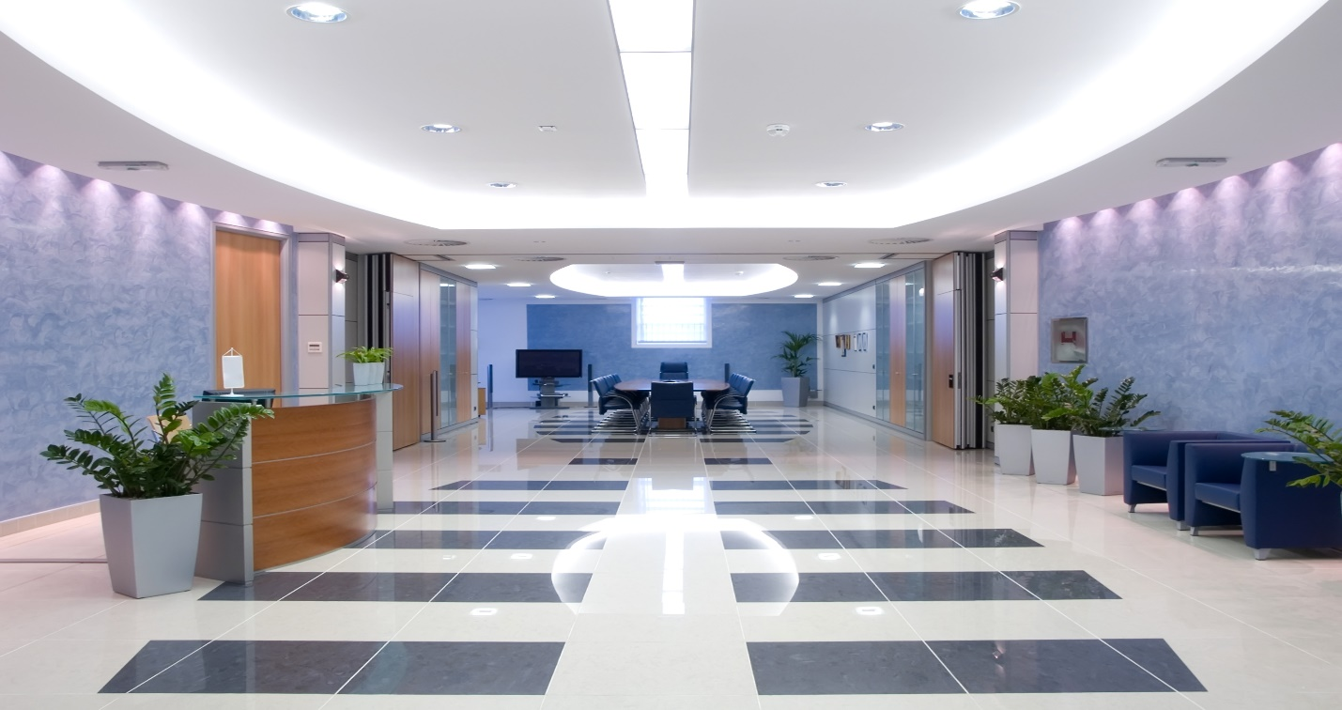

ServiceMaster Lake Forest IL - Residential and Commercial Specialty Service - ServiceMaster By Simons

ServiceMaster By Simons provides emergency Cleaning Services for commercial and residential properties in Lake Forest IL.
Lake Forest IL is one of the more secluded cities on Lake County Illinois’ water front. Originally settled in 1857, Lake Forest IL was a stop for people making their way down to Chicago from the north. One of the most scenic and historic neighborhoods includes eastern Lake Forest. Surrounded by prairies and nature preserves, Lake Forest is a magnificent city to live in if you are looking to live in relative comfort and seclusion.
ServiceMaster By Simons Lake Forest IL understands the significance of these beautiful homes and businesses, and therefore takes care to provide the very best services with an affinity for customer satisfaction. ServiceMaster By Simons, a woman-owned and family-operated company is an IICRC certified master textile restoration firm and has a convenient North Shore location. We can be at your home or business, providing excellent service on short notice - in most cases.
Our goal is to exceed your expectations with experienced staff members, the highest quality equipment, and above-and-beyond customer service. So when you need floor
For more information on ServiceMaster By Simons services call 847-316-9145 or click on our website to schedule your estimate, consultation and service.

ServiceMaster Lincolnwood IL - Residential & Commercial Services

ServiceMaster By Simons provides emergency Specialty Cleaning Services for Commercial & Residential properties in Lincolnwood IL
ServiceMaster By Simons, a woman-owned and family-operated firm, is proud to provide residents and businesses of Lincolnwood IL with emergency Specialty Cleaning services.
One of the most ethnically diverse communities in the Chicago-land area, Lincolnwood IL has one of the more "colorful" histories in the area including the now demolished Purple Hotel. Lincolnwood IL is considered one of the premiere communities to live and raise families because of its proximity to Chicago's downtown and the suburban feel that it offers to its residents.
As an IICRC Certified firm in Master Textile Restoration and a convenient Skokie location, you can rest assured that ServiceMaster By Simons will serve your property in a timely manner. Whether you’re a property owner, property manager, broker/agent or adjuster, we are the best choice for all of your Specialty Cleaning needs.
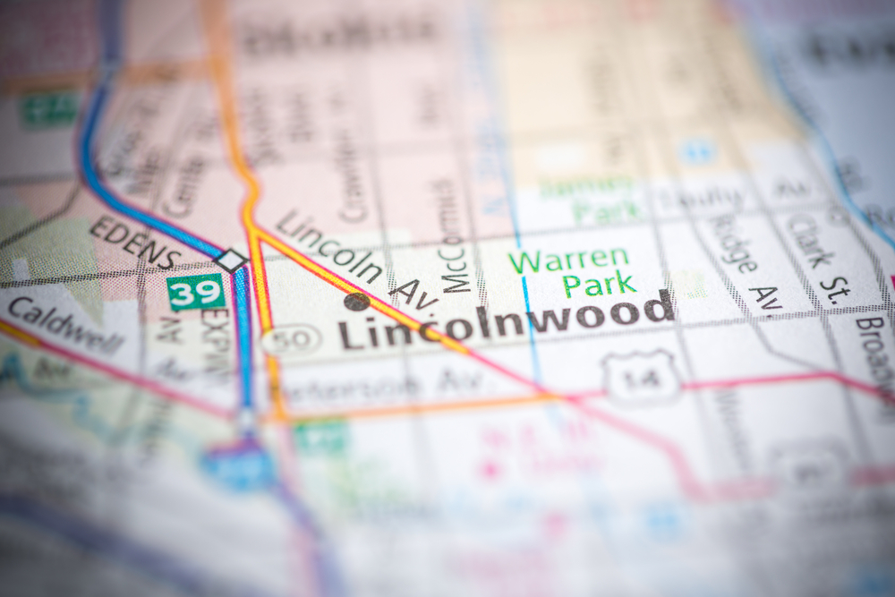
ServiceMaster By Simons is proud to serve the property owners of Lincolnwood Illinois.
Lincolnwood IL residents and businesses can call 847-316-9145 or toll free at 855-9-SIMONS to schedule an estimate, consultation or service.
You can also contact us on our website to schedule for service.

ServiceMaster Morton Grove IL – Commercial & Residential Services

ServiceMaster By Simons provides emergency Specialty Cleaning Services for commercial and residential properties in Morton Grove IL
ServiceMaster Morton Grove IL provides the very finest Specialty Cleaning Services to homes and businesses in Morton Grove IL. ServiceMaster By Simons, a woman-owned and family-operated company sets the standard in excellence as an IICRC Certified firm in Master Textile Restoration.
Bordered by Skokie, Niles, Des Plaines and Glenview, Morton Grove IL has a long history as a farming and logging community which eventually turned into a highly regarded community to raise a family.
When you're Morton Grove IL home or business requires expert services, it's important to depend on a company that represents the pinnacle of quality, professional, specialty services and the benchmark for customer satisfaction. Choose ServiceMaster By Simons. Our North Shore-Skokie location is just minutes away from neighboring Morton Grove IL. We can provide our expert, professional services to your home or business on the same day in most cases.
ServiceMaster By Simons' North Shore franchise is proud to have been serving Morton Grove for more than 30 years.
For more information on our restorative cleaning services, contact ServiceMaster By Simons at 847-316-9145 or call us toll free at 855-9-SIMONS.

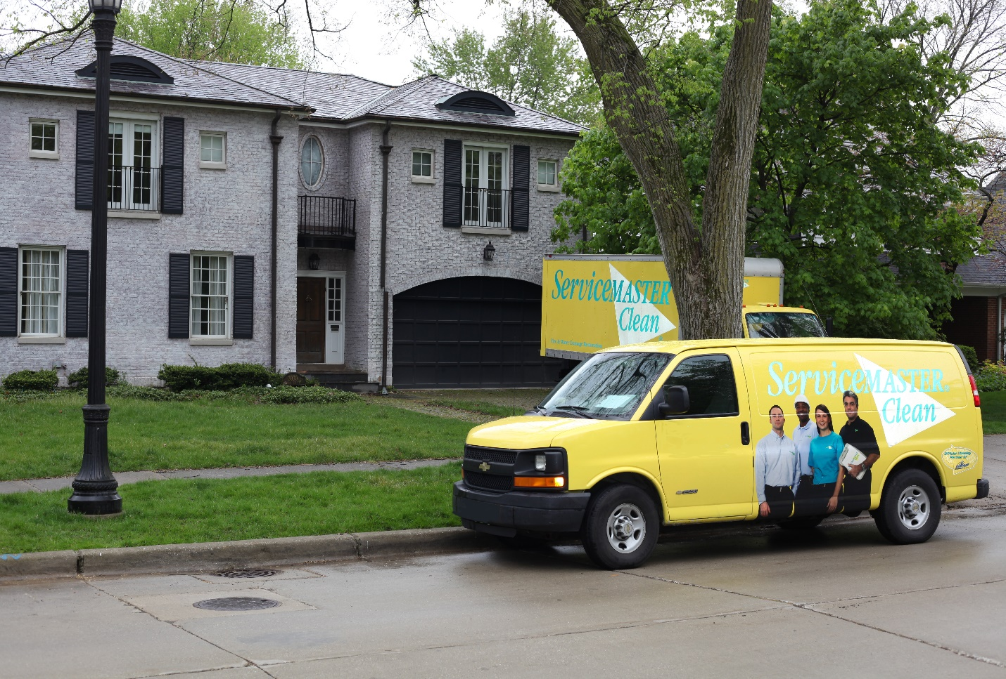

ServiceMaster Northbrook IL - Residential and Commercial Services -ServiceMaster By Simons

ServiceMaster By Simons provides Residential and Commercial Services to homes and businesses in Northbrook IL
ServiceMaster By Simons, a woman-owned and family-operated company is proud to serve the Northbrook IL community, its residents and business owners. IICRC Certified in Master Textile Restoration, ServiceMaster By Simons takes pride in the quality workmanship and customer service we offer our Northbrook IL customers.
ServiceMaster Clean is the benchmark of quality commercial and residential services since 1952. Serving 75,000 homes and businesses a day gives ServiceMaster the expertise and knowledge to better serve our customers. ServiceMaster By Simons employs IICRC certified technicians, providing your business or residence with the quality and care that it deserves.
For over 30 years, the ServiceMaster By Simons North Shore franchises have adhered to the strictest practices in Commercial and Residential Specialty services for the North Shore of Cook and Lake Counties.
Some of the Northbrook IL communities that we service include Northbrook Glen, Willow Cove, Woodoaks Glen, Estates of Charlemagne and Lane Park to name a few.
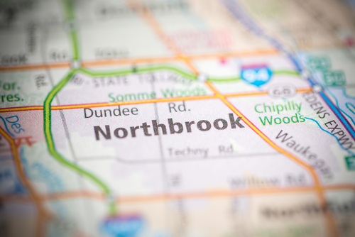
When searching for quality, professional Specialty Cleaning Services for your home or business, search no more.
ServiceMaster By Simons Northbrook IL offers estimates and consultations. Immediately call 847-316-9145 or contact us on our website to schedule your specialty cleaning service.

ServiceMaster Northfield IL-Residential & Commercial Services-Specialty Cleaning

ServiceMaster By Simons, the North Shore's leader in Residential & Commercial services, provides Specialty Cleaning to the residents and business-owners of Northfield IL.
ServiceMaster By Simons, a woman-owned and family-operated firm, is proud to offer Residential & Commercial Specialty Cleaning services to the residents and businesses of Northfield IL. We are an IICRC certified firm with master textile restoration as our specialty.
The Village of Northfield IL or the "Comfortable Corner of the North Shore" as its motto claims, is a special North Shore suburb. With its vast park system, exemplary schools and its gorgeous homes, Northfield IL is a great community to live and raise a family.
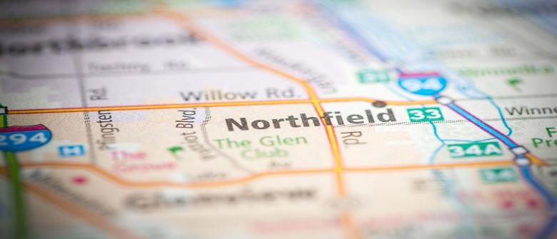
Trust ServiceMaster By Simons to provide the very best Specialty Cleaning Services for your Northfield IL property.
ServiceMaster By Simons doesn't just estimate the cost of the service you require, we consult with you. We discuss with you the best process and practice to getting your service completed.
ServiceMaster By Simons brand new state-of-the-art facility in Skokie IL, insures that our consultants or certified technicians will be out to your Northfield IL home or business in a jiffy.
Contact ServiceMaster here, or call us at 847-316-9145 or toll free at 855-9-SIMONS.

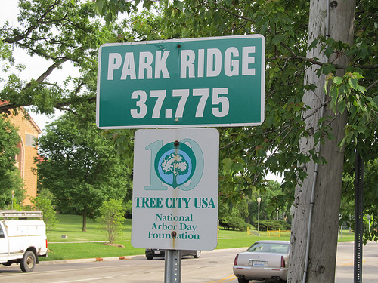

ServiceMaster Park Ridge IL - Commercial & Residential Specialty Cleaning - ServiceMaster By Simons

ServiceMaster Park Ridge IL provides professional Specialty Cleaning Services to homes and businesses in Park Ridge IL. Immediately call 847-316-9145 to schedule services.
ServiceMaster By Simons, a woman-owned and family-operated company, is proud to provide Specialty Cleaning Services to property owners, property managers, agents/brokers and adjusters of the Park Ridge Illinois community.
We have personal, wonderful memories of going to the Pickwick Theater as kids with our families and eventually with our friends as teens or taking our own children to the Wildwood Nature Center. We love Park Ridge!
You’re choosing the very best
When you choose ServiceMaster By Simons, be confident that you are choosing the best company for specialty cleaning services for your home or business.
With our convenient warehouse location in Skokie Illinois, you can rest assured that you will be served in a timely manner.
Give Us A Call!
Call us at 847-316-9145 to schedule your service or a consultation or you can click here and schedule on our website.

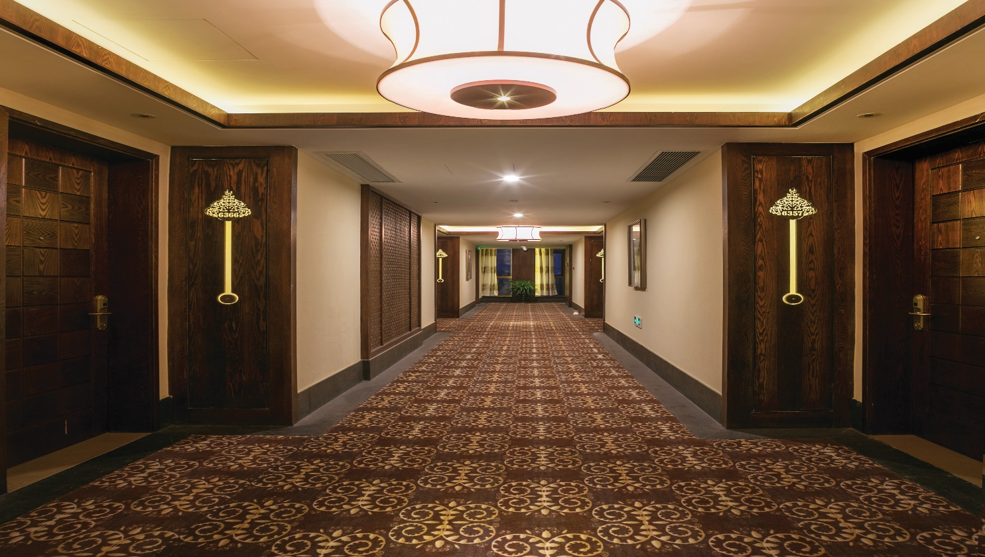

ServiceMaster Rosemont IL – Commercial and Residential Specialty Cleaning - ServiceMaster By Simons

ServiceMaster By Simons provides emergency cleaning services to homes and businesses in Rosemont IL.
Rosemont IL is one of Chicago's hub for shopping, restaurants and entertainment. Our personal favorite is the Fashion Outlet Mall and Ossobucco D’Agnello at Carlucci’s afterward! With its close proximity to O'Hare Airport and Chicago's downtown, Rosemont is busy!
ServiceMaster By Simons is at your home or business in Rosemont IL in a hurry!
The name you can trust, ServiceMaster By Simons, a woman-owned and family-operated firm, employs only IICRC trained technicians. As a master textile restoration firm, we assure you that we will take the best care of your property. We provide excellent Specialty Cleaning service and strive for your satisfaction.
With our convenient Skokie Illinois location, we can have an estimator and crew out to your property in a hurry.
Whether you’re a property-owner, property-manager, broker/agent or an adjuster, you can rest assured that ServiceMaster By Simons will provide top-level Specialty Cleaning services for your residential or commercial property.
Call Us Now!
Call ServiceMaster By Simons at 847-316-9145 to schedule you service or click on our website for more information.

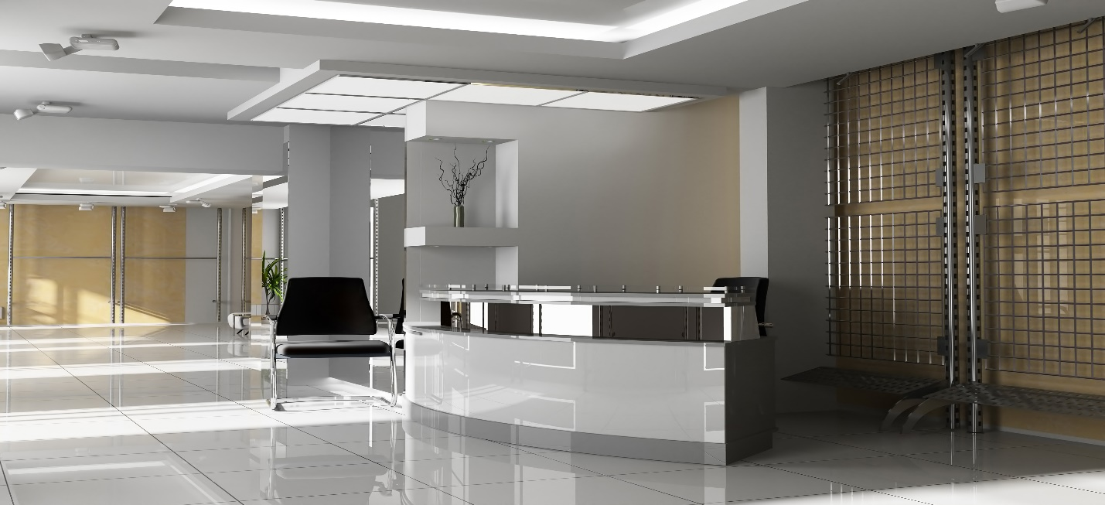

ServiceMaster Skokie IL - Commercial and Residential Specialty Cleaning Services - Skokie Location

ServiceMaster By Simons provides emergency Specialty Cleaning services to Commercial and Residential properties in Skokie IL
What was once predominantly a residential village, Skokie IL is fast becoming a North Shore destination for restaurants, entertainment and retail shopping. With communities like Village Crossing, Old Orchard and the Touhy/McCormick corridor and its proximity to the water-front ServiceMaster By Simons commercial services are in high demand.
ServiceMaster Near Me
ServiceMaster By Simons' North Shore location in Skokie Illinois is a new 10,000 sq foot facility equipped for providing the very best Specialty Cleaning services to commercial and residential properties in the Village of Skokie IL and the North Shore. As proud community members and a Skokie Chamber of Commerce business, you can rest assured that you are receiving the pinnacle of service from ServiceMaster By Simons.
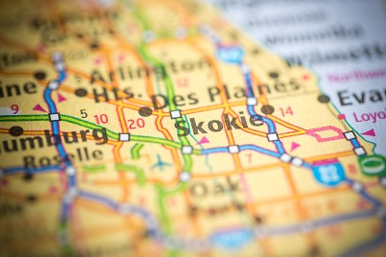
ServiceMaster By Simons is a woman-owned and family-operated business that stands by our award-winning services and special attention to customer service and satisfaction. We are an IICRC certified master textile restoration firm which means we pay special attention to your properties furnishings and textiles.
When you are looking for emergency Specialty Cleaning services for your home or business, call ServiceMaster By Simons. We are Skokie Illinois' leader in Specialty Cleaning services. Contact us here, or call us at 847-316-9145. We'll evaluate and estimate your service same day.

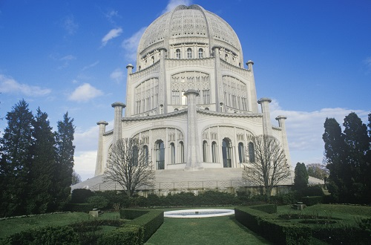

ServiceMaster Wilmette IL - North Shore Specialty Cleaning Services - ServiceMaster By Simons

For emergency Specialty Cleaning Services, ServiceMaster By Simons is the Wilmette IL leader.
ServiceMaster Near Me
ServiceMaster By Simons is a woman-owned and family-operated Specialty Cleaning firm that takes great pride in providing the very best emergency specialty cleaning services for residential and commercial properties in Wilmette Illinois. As proud community members and part of the Wilmette Chamber of Commerce, you can rest assured that we have “Quality Service” on our minds.
Part of the New Trier Township, Wilmette Illinois is considered one of the North Shore's gems. East of the Interstate 90 corridor and bordered by water front on beautiful Lake Michigan, Wilmette is a North Shore destination point for many seeking a thriving shopping and dining experience and sight-seeing some of the most beautiful water front homes. Visit historic CAGE, Baha’i House of Worship and stunning, legendary architecture.
With this much history and architecture in Wilmette IL, it takes a special company to care for the homes and businesses in this great community. That's why ServiceMaster By Simons, an IICRC certified textile restoration firm, has expanded its territories to include this gem of the North Shore. ServiceMaster is committed to providing the very best Specialty Cleaning Services to home and business-owners.
Give us a call at 847-316-9145 to learn about our services. Or CLICK HERE to schedule your service today!

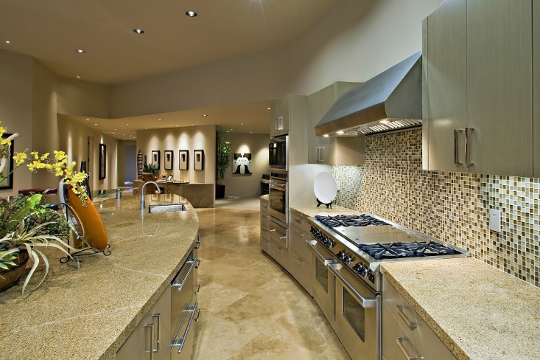

ServiceMaster Winnetka IL – Residential and Commercial Specialty Cleaning Service

ServiceMaster By Simons provides emergency Specialty Cleaning services to residents and business owners in Winnetka IL
Winnetka IL ServiceMaster Near Me
When you need Specialty Cleaning services for your Winnetka property, you think of ServiceMaster - you call ServiceMaster By Simons, the benchmark in commercial & residential Specialty Cleaning services for Winnetka Illinois.
ServiceMaster Clean opened its doors in 1952 offering specialty cleaning services to many of the water from communities on the north shore including Winnetka IL.
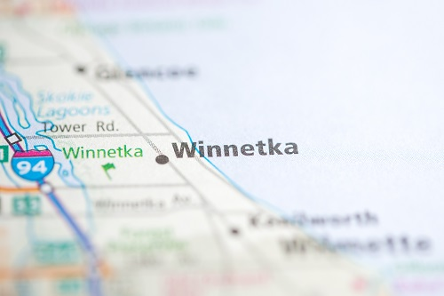
ServiceMaster By Simons, a woman-owned and family-operated firm is the north shore's leader in specialty cleaning services. We are an IICRC certified Master Textile Restoration firm.
ServiceMaster By Simons' second location in Skokie Illinois means that we are minutes away from providing you with fast and excellent service. So give us a call!
In an emergency, ServiceMaster By Simons is at the ready to provide the excellent service that you deserve. Call ServiceMaster By Simons now at 847-316-9145. We'll provide a free quote for services to your Winnetka property.

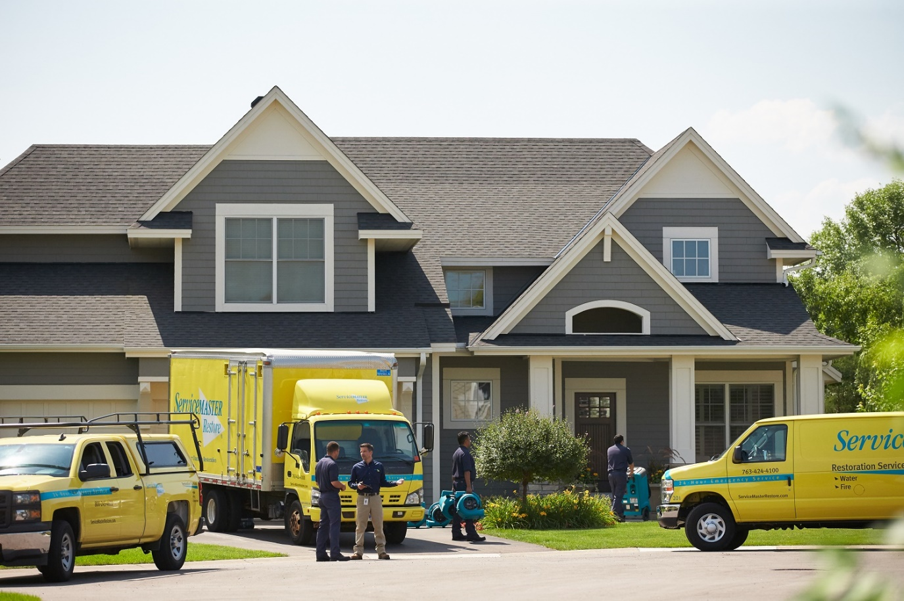

ServiceMaster Chicago Illinois – Water & Fire Damage Restoration – Commercial and Residential Services – Property Cleaning – Remediation - Restoration Services

ServiceMaster Restoration By Simons, nationally certified disaster restoration services for Commercial & Residential properties in Chicago Illinois.

Water & Fire Damage Restoration Near Me
ServiceMaster Restoration By Simons is a woman-owned and family-operated cleaning & restoration company located in Chicago’s Near North community that provides
- Water & Flood Damage Restoration
- Fire & Smoke Damage Restoration
- Mold Remediation services
as well as Specialty Cleaning services including
- Post-Construction Cleaning
- Clutter Cleaning
- Carpet Cleaning
- Upholstery Cleaning
for the many residents and business-owners of Chicago Illinois.
From Pilsen to Prairie District, Lincoln Park to Galewood or Rogers Park to Edison Park, ServiceMaster Restoration By Simons has got you covered. We are an IICRC certified firm with nationally certified Master Water Restorers, Master Fire Restorers and Master Textile Restorers on staff. That means we know what we’re talking about when it comes to the Cleaning and Restoration of your commercial or residential property.
Don’t just take our word for it. Check out our great reviews, search the great blogs and articles about us on the web or checkout our website at https://servicemaster-restorationbysimons.com/
With our convenient location in Chicago’s City Center, we get out to your property quickly and prepared to clean and restore you home – FAST!
Whether you are a Property Owner, Property Manager, Insurance Agent/Adjuster or a Real Estate Broker/Agent, ServiceMaster Restoration By Simons has got you covered. We own and maintain the industries best restoration equipment for fire & water damage restoration and we’ve got PLENTY of it!
- Air Movers
- Dehumidifiers
- Wood Floor Drying Systems
- Negative Air Scrubbers
- Water Extractors
- Odor Elimination Machines
State-of-the-art moisture detecting systems including
- Thermal Imaging Cameras
- Moisture Measurement Systems
- Hygrometers

If you’ve had Water Damage or Flood Damage as a result of sewer backup, freezing and breaking pipes, a faulty hot water heater or washing machine or that pesky dishwasher, call us immediately!
And if your property is affected by Fire or Smoke Damage from a fire in your property or the property next door or you forgot dinner on the stove, call us immediately!
Call us at 773-376-1110 or toll free at 855-9-SIMONS
Or, contact us on our website and set up your appointment for Cleaning or Restoration services.
ServiceMaster Restoration By Simons has got you covered.

